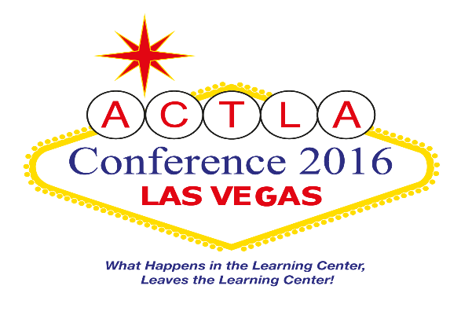

What Happens in the Learning Center, Leaves the Learning Center
April 20-April 23, 2016

Conference at a Glance

Wednesday, April 20, 2016
ACTLA Board Meeting 2:00pm – 5:00pm
ACTLA Board Dinner 5:00pm – 6:00pm

Thursday, April 21, 2016
ACTLA Conference Registration 7:00am – 4:00pm
Full Day Pre-Conference Sessions 9:00am – 4:00pm
AM Pre-Conference Sessions 9:00am – 12:00pm
PM Pre-Conference Sessions 1:00pm – 4:00pm
Exhibit Hall Set Up 1:00pm – 4:00pm
Conference Kick-Off and Entertainment 5:00pm – 6:00pm
Event: Tour of the Strip 6:00pm – 9:00pm

Friday, April 22, 2016
Conference Registration 7:00am – 5:00pm
Exhibit Hall 7:30am – 5:00pm
Welcome Breakfast 8:00am – 9:00am
AM Concurrent Workshops (15 Breakout Sessions) 9:00am – 12:20pm
Keynote Luncheon 12:30pm – 2:00pm
PM Concurrent Workshops (10 Breakout Sessions) 2:10pm – 4:20pm
ACTLA Board Meeting 5:00pm – 6:00pm

Saturday, April 23, 2016
Conference Registration 7:00am – 10:00am
Exhibit Hall 7:30am – 12:30pm
Breakfast 8:00am – 9:00am
AM Concurrent Workshops (15 Breakout Sessions) 9:00am – 12:20pm
Lunch on Your Own 12:30pm – 1:00pm
ACTLA Board Meeting 1:00pm – 4:00pm

Registration opens September 30th! The link will be available soon.

Hotel, Parking and Transportation

- CONFERENCE HOTEL
The official conference hotel is the Rio All-Suite Hotel and Casino at 3700 W. Flamingo Road
Las Vegas, NV 89103; (888) 746-6955. ACTLA’s special group rate of $119/night (not including tax and resort fee) is available until March 20, 2016 (or until our room block is sold out!). Come early or stay longer to enjoy the Las Vegas area (the special room rate is available from April 17th through April 25th). Parking during these dates is FREE. Register online using this link: Rio Hotel

- PARKING
Parking is free during the conference dates April 17-24, 2016.

- TRANSPORTATION

Airport/Flight
McCarran International Airport
5757 Wayne Newton Blvd, Las Vegas, NV 89119
(702) 261-5211
https://www.mccarran.com

Shuttle Bus from the Airport
Showtime Tours
(702) 895-9976
http://www.showtimetourslv.com
Starting at $7.50 (one way); Roundtrip discount also available

Bell Trans
(702) 385-5466
www.bell-trans.com
Contact for shuttle price

Taxi
There are various taxi services available at the airport. Please use a reputable taxi service such as Ace Cab, Checkered Cab, etc.
https://www.mccarran.com/Go/Taxis.aspx

Conference Registration
Professional Registration
Conference Registration | Amount | Paid By | Stipulations
Full Day – Early Bird | $290.00 | 9/4/15 - 1/31/16 | payment must be made at time of registration or postmarked within 30 days of registration; if it is not postmarked, you will be charged the full registration fee
Full Conference (no Early Bird) | $340.00 | 2/1/16 – 3/31/16 | payment must be made at time of registration or postmarked by 4/1/16. After 4/1/16, please bring your check with you to the conference
Late Full Conference Registration | $390.00 | Paid after 4/1/16 | payment must be made at time of registration or bring your check with you to the conference
Single Day Registration – Early Bird | $190.00 | 9/4/15 - 1/31/16 | payment must be made at time of registration or postmarked within 30 days of registration; if it is not postmarked, you will be charged the full registration fee
Single Day Registration ( no Early Bird) | $240.00 | 2/1/16 – 3/31/16 | payment must be made at time of registration or postmarked by 4/1/16. After 4/1/16, please bring your check with you to the conference
Late Single Day Registration | $290.00 | Paid after 4/1/16 | payment must be made at time of registration or bring your check with you to the conference

Student (not in a professional position)/Retiree Conference Rates
Conference Registration | Amount | Paid By | Stipulations
Full Day – Early Bird | $190.00 | 9/4/15 - 1/31/16 | payment must be made at time of registration or postmarked within 30 days of registration; if it is not postmarked, you will be charged the full registration fee
Full Conference (no Early Bird) | $240.00 | 2/1/16 – 3/31/16 | payment must be made at time of registration or postmarked by 4/1/16. After 4/1/16, please bring your check with you to the conference
Late Full Conference Registration | $290.00 | Paid after 4/1/16 | payment must be made at time of registration or bring your check with you to the conference
Single Day Registration | Same as Professional Cost (listed in first table)

ACTLA Board Members
Conference Registration | Amount | Paid By | Stipulations
Full Conference and Single Day Registrations | $0 | Must register by Early Bird deadline using promotional code | ACTLA Board members includes only elected or appointed Board members that are currently active (2015-2016)

Pre-Conferences
April 21, 2015
Lunch is not included in any of the pre-conferences
Full Day  9:00am – 4:00pm | Amount | Paid By
Improving Reading Across Disciplines – One Tutorial Session at a Time: A Reading Apprenticeship Approach for Tutoring | $100.00 | 4/1/2016
Transforming Good Students into Great Learners: A Metacognitive Learning Approach | $100.00 | 4/1/2016
Half Day (morning)  9:00am – 12:00pm | Amount | Paid By
CRLA Certifications: International TUTOR Training Program Certification (ITTPC) | $60.00 | 4/1/2016
Half Day (afternoon)  1:00pm – 4:00pm | Amount | Paid By
100 Amazing Strategies and Resources for “Wowifying” Tutor Training and Improving Student Outcomes | $60.00 | 4/1/2016
Both morning and afternoon sessions | $100.00 | 4/1/2016

Registration Fees include a one-year ACTLA membership.

Refund Policy
- Written requests for refunds of 75% of conference registration fees must be received or postmarked prior to Monday, December 29, 2015.
- Written requests for refunds of 50% of conference registration fees must be received or postmarked prior to Sunday, February 15, 2016.
- No refunds of conference registration fees will be issued after Sunday, February 15, 2016. Extenuating circumstances such as serious illness or injury, death of a family member, or unforeseeable emergency will be considered on a case-by-case basis. Documentation may be required. There will be a charge of 50% of conference registration fees to cover unrecoverable food and hotel costs.
- All written requests for refunds of conference registration fees must be sent to the ACTLA President, Ms. Tabitha Villalba (Tabitha.villalba@fresnocitycollege.edu)
